INTEGRATIVE COURSE IN PSYCHOLOGY (ICOPSYCH)

ANALYSIS ON THE RESULT OF PRE-TEST EXAMINATION IN INDUSTRIAL PSYCHOLOGY
MAY 24, 2025

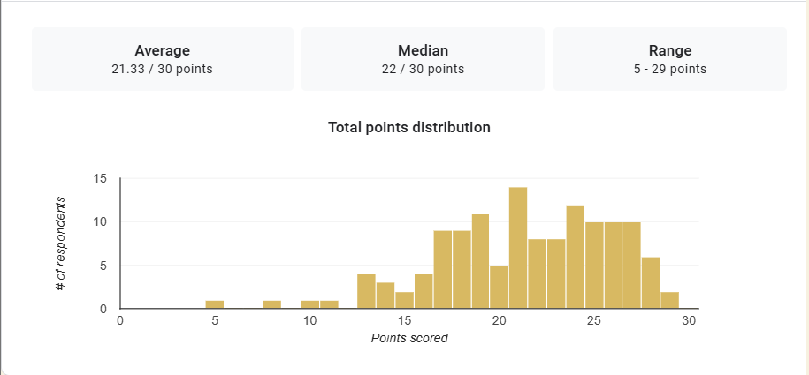

1. Mean Score: The mean (average) score of 21.33 suggests that, overall, participants performed reasonably well on the test. This is 71.1% of the total possible score, indicating a moderate to high level of understanding or performance.

2. Median Score: The median score, or the middle score when all are ordered, is 22, slightly higher than the mean. Half of the test takers scored above 22, and half scored below.

3. Range: The range of scores is from 5 to 29, giving a spread of 24 points. It may suggest a mixed group in terms of skill level, understanding, or test preparedness.

Interpretation Summary:

-The average performance (mean = 21.33) was fairly strong, but slightly below the midpoint score (median = 22), indicating some lower outliers.

-The wide range (5–29) suggests a diverse group with varying ability levels.

-Overall, most participants did relatively well, but some performed poorly enough to bring down the mean slightly.

RATIONALIZATION:

DIFFICULT QUESTIONS:

